**MOVIE MINGLE**

**A PROJECT REPORT**

**for**

**Project (KCA451)**

**Session (2023-24)**

**Submitted by**

**HARISH KUMAR SHARMA**

**(2200290140062)**

**Submitted in partial fulfilment of the**

**Requirements for the Degree of**

**MASTER OF COMPUTER APPLICATION**

**Under the Supervision of**

### Ms. Shruti Aggarwal

### (Teaching Assistant)



**Submitted to**

**Department Of Computer Applications**

**KIET Group of Institutions, Ghaziabad**

**Uttar Pradesh-201206**

**(May-24)**

**CERTIFICATE**

Certified that **HARISH KUMAR SHARMA (2200290140062)** has/ have carried out the project work having “**MOVIE MINGLE**.” (**Project-KCA451**) for **Master of Computer Application** from Dr. A.P.J. Abdul Kalam Technical University (AKTU**)** (formerly UPTU), Lucknow under my supervision. The project report embodies original work, and studies are carried out by the student himself/herself and the contents of the project report do not form the basis for the award of any other degree to the candidate or to anybody else from this or any other University/Institution.

**Date: 25th May 2024**

**HARISH KUMAR SHARMA (2200290140062)**

This is to certify that the above statement made by the candidate is correct to the best of my knowledge.

Date: 25th May 2024

**Ms. Shruti Aggarwal Dr. Arun Tripathi**

**Teaching Assistant Head**

**Department of Computer Applications Department of Computer Applications**

**KIET Group of Institutions, Ghaziabad KIET Group of Institutions, Ghaziabad**

**ACKNOWLEDGEMENTS**

Success in life is never attained single-handedly. My deepest gratitude goes to my project supervisor, **Ms. Shruti Aggarwal** for his/ her guidance, help, and encouragement throughout my project work. Their enlightening ideas, comments, and suggestions.Words are not enough to express my gratitude to Dr. Arun Kumar Tripathi, Professor and Head, Department of Computer Applications, for his insightful comments and administrative help on various occasions.

Fortunately, I have many understanding friends, who have helped me a lot on many critical conditions.

Finally, my sincere thanks go to my family members and all those who have directly and indirectly provided me with moral support and other kind of help. Without their support, completion of this work would not have been possible in time. They keep my life filled with enjoyment and happiness.

**HARISH KUMAR SHARMA**

**(2200290140062)**

# ABSTRACT

Recommendation System is a system that seeks to predict or filter preferences according to the user’s choices. Recommendation systems are utilized in a variety of areas including movies, music, news, books, research articles, search queries, social tags, and products in general, It is a simple algorithm whose aim is to provide the most relevant information to a user by discovering patterns in a dataset. The algorithm rates the items and shows the user the items that they would rate highly. An example of recommendation in action is when you visit Amazon and you notice that some items are being recommended to you or when Netflix recommends certain movies to you. They are also used by Music streaming applications such as Spotify and Deezer to recommend music that you might like. They gradually learn your preferences over time and suggest new products which they think you’ll love. We can make this application using python language and collaborative based filtering algorithm. Collaborative filtering tackles the similarities between the users and items to perform recommendations.

We include a data set with user id, ratings, item number and time spent. With these data we use mapping technique and correlation concept to match user id and ratings. The next movie recommendation should be based on the user’s rating to watched movies.

## TABLE OF CONTENT

INTRODUCTION… 1

PROBLEM STATEMENT 2

OBJECTIVE 3

METHODOLOGY 4

ORGANISATION… 14

LITERATURE SURVEY

Matrix Factorization Model in Collaborative Filtering Algorithms… 15

Latent Factor Models for Web Recommender System… 15

Matrix Factorization Techniques for Recommender Systems… 16

Related Articles and Research Papers… 17

SYSTEM DESIGN

Dataset 18

Visualizing the no. of users Voted… 19

Visualizing the no. of Votes by User 20

Algorithms Used… 21

Hardware and Software Requirements… 24

Concepts Requirements… 24

PERFORMANCE ANALYSIS

Comparisons and Results 25

CONCLUSIONS

Conclusion 34

Future Work… 36

REFERENCES 37

|  |  |  |
| --- | --- | --- |
| **LIST OF FIGURES** |  |  |
| **FIGURE No.** | **FIGURE NAME** | **PAGE No.** |
| 1 | SYSTEM ARCHITECTURE | 4 |
| 2 | COLLBORATIVE FILTERING (CF) | 10 |
| 3  4 | USER BASED FILTERING  OUTPUT | 11  19 |

Chapter 1

**INTRODUCTION**

Suggestion frameworks square measure the frameworks that square measure used to accumulate shopper fascination by understanding the client's style. These frameworks have currently become thought because of their capability to allow customised substance to shoppers that square measure of the client's advantage. Nowadays an outsized range of things square measure recorded on net business sites that create it tough to get a results of our ideal call. This is often the place wherever these frameworks assist United States by apace suggesting United States with the perfect things. Proposal frameworks facilitate shoppers notice and choose things (e.g., books, motion photos, eateries) from the big variety accessible on the online or in different electronic knowledge sources. Given a massive arrangement of things and a portrayal of the client's needs, they gift to the consumer a bit arrangement of the items that square measure applicable to the depiction. Also, a movie proposal framework provides a degree of solace and personalization that assists the consumer with collaborating the framework and watch motion photos that take into consideration his needs. Giving this degree of solace to the consumer was our essential inspiration in choosing film proposal framework as our BE Project. The most reason for our framework is to impose motion photos to its shoppers obsessed with their review history and evaluations that they provide. The framework can likewise impose totally different E-trade organizations to advertise their things to specific shoppers obsessed with the categoryof films they like. Made-to-order proposal motors facilitate a large variety of people slender the universe of doubtless movies to accommodate their exceptional tastes. Community separating and content based mostly winnow square measure the square measure prime ways in which to traumatize provide suggestion to shoppers. The 2 of them square measure best relevant in specific things in light-weight of their explicit smart and dangerous times. During this paper we've projected a emulsified methodology with the tip goal that each the calculations supplement one another consequently rising presentation and exactness of the of our framework

### RELATED WORK

Film proposals utilizing a number of procedures are widely targeted within the previous a few years. Models incorporate a proposal framework utilizing the ALS calculation, a suggestion smitten by the coefficient procedure, thing likeness based mostly synergistic separation. These procedures would like earlier information regarding the appraisals for the motion photos that square measure made by the shopper. These strategies significantly use film attentiveness datasets

for assessment functions. Nonetheless, these frameworks aren't somewhat actual, and analysis is continuous to boost the continuing exhibition of those frameworks. Style and Implementation of cooperative Filtering Approach utilizing KNN Cui, Bei-Bei[2] has self-addressed the suggestion framework Utilizing the rating and likeness among the 2 clients; the framework prescribes an issue to the shopper for the dynamic. At that time separate the film informational index into Associate in nursing unrated and evaluated take a look at set with the help of the KNN model. It will counsel the motion photos to the obscure shoppers through shopper tour of duty information, furthermore, it will create new and not thought film suggestions as indicated by the film's set of experiences and score. The info set during this approach is that the MYSQL data base. The tour of duty framework for a shopper can snap the client's outer and interior conduct qualities, and these attributes square measure place away within the shopper information base through a login module for the shopper. The to a lower place figure.1.Portrays their compelling technique of approach for a collective sifting approach utilizing KNN. Comparison with completely different calculations. In [4], Goutham Miryala projected an identical investigation of ALS on completely different calculations. still, it's seen that utilizing a additional broad making ready dataset of 80-20 (Training - Testing) yields a model that includes a lower RMSE once contrasted with the 60-40 (Preparing - Testing) dataset. The result shows that the upper regularization boundary expands RMSE and therefore the different method around. The ALS calculation is contrasted and SVD, KNN, and Normal Indicator, and therefore the outcomes show that ALS is that the best calculation for the suggestion framework.

## EXISTING SYSTEM

The most well-known sorts of suggestion frameworks square measure content-based and shared separation recommendation frameworks. In shared separation, the conduct of a gatheringof shoppers is employed to form proposals to completely different shoppers. The suggestion depends on the inclination of various shoppers. An easy model would bring down a movie to a shopper smitten by the method that their companion treasured the film. There square measure 2 styles of communitarian models Memory-based ways and Model-based techniques. The top of memory-based strategies is that {they square straightforward to actualize and therefore the succeeding suggestions are frequently straightforward to clarify. they're divided into two: User-based synergistic sifting: during this model, things square measure prescribed to a shopper smitten by the method that the things are most wellliked by shoppers just like the shopper. For example : if Derrick and Dennis like similar films and another film begin that Derick like, at that time we will bring down that film to Dennis in lightweight of the very fact that Derrick and Dennis seem to love similar motion photos. Item-based cooperative separating:

These frameworks acknowledge comparative things smitten by clients' past evaluations. for example, if shoppers A, B, and C gave a 5-star rating to books X and Y then once a shopper D purchases book Y they likewise get a suggestion to shop for book X on the grounds that the framework distinguishes book X and Y as comparative smitten by the evaluations of shoppers A, B, and C. Model-put a long ways square measure based mostly with relevance Matrix resolving and square measure higher at managing scantiness. They’re created utilizing data mining, AI calculations to anticipate clients' evaluating of unrated things. During this methodology procedures, for instance, spatiality decrease square measure used to boost truth. Instances of such model-based ways incorporate call trees, Rule-based Model, theorem Model, and inert issue models. Content-based frameworks use data like category, maker, someone, entertainer to counsel things say motion photos or music. Such a proposal would be for instance suggesting eternity War that enclosed Vin Diesel since someone watched and enjoyed The Fate of the Furious. Also, you'll get music proposals from specific specialists since you really liked their music. Content-put along frameworks square measure based mostly with relevance the chance that within the event that you simply most well-liked a particular issue you're well on the thanks to like one thing that's love it.

## DISADVANTAGES

* + - It does not work for one more shopper UN agency has not appraised any issue nevertheless as enough appraisals square measure needed substance based mostly recommendation assesses the shopper inclinations and provides actual proposals. Complex interface
    - No suggestion of lucky things.
    - Limited Content Analysis-The recommendation does not work if the framework neglects to acknowledge the items cap a shopper likes from the items that he does not look after.

## PROPOSED SYSTEM

Collaborative filtering (CF) is one of the most widely adopted and successful recommendation approaches. Unlike many content-based approaches which utilize the attributes of users and items, CF approaches make predictions by using only the user-item interaction information. These methods can capture the hidden connections between users and items and have the ability to provide serendipitous items which are helpful to improve the diversity of recommendation. recommendation systems have been indispensable nowadays due to the incredible increasing of information in the world, especially on the Web. These systems apply knowledge discovery techniques to make personalized recommendations that can help people sift through huge amount of available articles, movies, music, web pages, etc. Popular examples of such systems include product recommendation in Amazon, music recommendation in Last.fm, and movie recommendation in Movie lens.

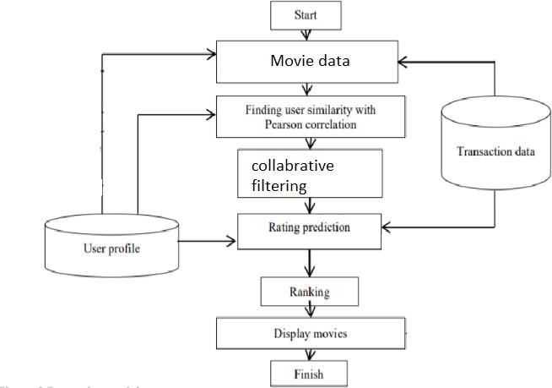

## FIG 1 SYSTEM ARCHITECTURE

**ADVANTAGES OF THE PROPOSED SYSTEM**

* + - It is subject to the association between shoppers that suggests that it's contentautonomous. Scalable client administrations.
    - CF recommendation frameworks will propose lucky things by noticing comparative leaning individuals' conduct.
    - They will create real quality analysis of things by considering completely different folks teams insight.

### CHAPTER 2

### LITERATURE SURVEY

Movie recommendation system is based on collaborative filtering approach. Collaborative filtering makes use of information provided by user. That information is analyzed and a movie is recommended to the users which are arranged with the movie with highest rating first. Luis M Capos et al has analyzed two traditional recommendation systems i.e. content based filtering and collaborative filtering. As both of them have their own drawbacks he proposed a new system which is a combination of Bayesian network and collaborative filtering. A hybrid system has been presented by Harpreet Kaur et al. The system uses a mix of content as well as collaborative filtering algorithm. The context of the movies is also considered while recommending. The user - user relationship as well as user - item relationship plays a role in the recommendation. The user specific information or item specific information is clubbed to form a cluster by Utkarsh Gupta et al. using chameleon. This is an efficient technique based on Hierarchical clustering for recommendation system. To predict the rating of an item voting system is used. The proposed system has lower error and has better clustering of similar items. Urszula Kużelewska et al. proposed clustering as a way to deal with recommendation systems. Two methods of computing cluster representatives were presented and evaluated. Centroid-based solution and memory-based collaborative filtering methods were used as a basis for comparing effectiveness of the proposed two methods. The result was a significant increase in the accuracy of the generated recommendations when compared to just centroid-based method. Costin-Gabriel Chiru et al. proposed Movie Recommendation, a system which uses the information known about the user to provide movie recommendations. This system attempts to solve the problem of unique recommendations which results from ignoring the data specific to the user. The psychological profile of the user, their watching history and the data involving movie scores from other websites is collected. They are based on aggregate similarity calculation. The system is a hybrid model which uses both content based filtering and collaborative filtering. To predict the difficulty level of each case for each trainee Hongli LIn et al. proposed a method called contentboosted collaborative filtering (CBCF).The algorithm is divided into two stages, First being the content-based filtering that improves the existing trainee case ratings data and the second being collaborative filtering that provides the final predictions. The CBCF algorithm involves the advantages of both CBF and CF, while at the same time, overcoming both their disadvantages.

### CHAPTER 3

### METHODOLOGY

* 1. **AIM OF THE PROJECT**

To implement a recommendation for movies, based on the content of providing the most relevant information to a user by discovering patterns in a dataset. The algorithm rates the items and shows the user the items that they would rate highly.

### SYSTEM REQUIREMENTS

### SOFTWARE REQUIREMENTS

* + - * Operating system : Windows 7 and above (64-bit).
      * Python : 3.6

### HARDWARE REQUIREMENTS

* + - * Hard disk : 80GB or more
      * Ram : 70Mb or more
      * Processor : : Intel Core Duo 2.0 GHz or more

### OVERVIEW OF THE PLATFORM

#### Python

Python is a widely used general-purpose, high level programming language. It was initially designed by Guido van Rossum in 1991 and developed by Python Software Foundation. It was mainly developed for emphasis on code readability, and its syntax allows programmers to express concepts in fewer lines of code.

Python is a programming language that lets you work quickly and integrate systems more efficiently.

#### What can Python do?

* Python can be used on a server to create web applications.
* Python can be used alongside software to create workflows.
* Python can connect to database systems. It can also read and modify files.
* Python can be used to handle big data and perform complex mathematics.
* Python can be used for rapid prototyping, or for production-ready software development.

#### Why Python?

* Python works on different platforms (Windows, Mac, Linux, Raspberry Pi, etc).
* Python has a simple syntax similar to the English language.
* Python has syntax that allows developers to write programs with fewer lines than some other programming languages.
* Python runs on an interpreter system, meaning that code can be executed as soon as it is written. This means that prototyping can be very quick.
* Python can be treated in a procedural way, an object-orientated way or a functional way

#### Good to know

* The most recent major version of Python is Python 3, which we shall be using in this tutorial. However, Python 2, although not being updated with anything other than security updates, is still quite popular.
* Python 2.0 was released in 2000, and the 2.x versions were the prevalent releases until December 2008. At that time, the development team made the decision to release version 3.0, which contained a few relatively small but significant changes that were not backward compatible with the 2.x versions. Python 2 and 3 are very similar, and some features of Python 3 have been backported to Python 2. But in general, they remain not quite compatible.
* Both Python 2 and 3 have continued to be maintained and developed, with periodic release updates for both. As of this writing, the most recent versions available are 2.7.15 and 3.6.5. However, an official End of Life date of 9 January 1, 2020 has been established for Python 2, after which time it will no longer be maintained.
* Python is still maintained by a core development team at the Institute, and Guido is still in charge, having been given the title of BDFL (Benevolent Dictator For Life) by the Python community. The name Python, by the way, derives not from the snake, but from the British comedy troupe Monty Python’s Flying Circus, of which Guido was, and presumably still is, a fan. It is common to find references to Monty Python sketches and movies scattered throughout the Python documentation.
* It is possible to write Python in an Integrated Development Environment,such as Thonny, Pycharm, Netbeans or Eclipse which are particularly useful when managing larger collections of Python files.

#### Python Syntax compared to other programming languages

* Python was designed to for readability, and has some similarities to the English language with influence from mathematics. Python uses new lines to complete a command, as opposed to other programming languages which often use semicolons or parentheses. Python relies on indentation, using whitespace, to define scope; such as the scope of loops, functions and classes. Other programming languages often use curly-brackets for this purpose. Python is Interpreted Many languages are compiled, meaning the source code you create needs to be translated into machine code, the language of your computer’s processor, before it can be run. Programs written in an interpreted language are passed straight to an interpreter that runs them directly.
* This makes for a quicker development cycle because you just type in your code and run it, without the intermediate compilation step.
* One potential downside to interpreted languages is execution speed. Programs that are compiled into the native language of the computer processor tend to run more quickly than interpreted programs. For some 10 applications that are particularly computationally intensive, like graphics processing or intense number crunching, this can be limiting.
* In practice, however, for most programs, the difference in execution speed is measured in milliseconds, or seconds at most, and not appreciably noticeable to a human user. The expediency of coding in an interpreted language is typically worth it for most applications.
* For all its syntactical simplicity, Python supports most constructs that would be expected in a very high-level language, including complex dynamic data types, structured and functional programming, and object-oriented programming

.

* Additionally, a very extensive library of classes and functions is available that provides capability well beyond what is built into the language, such as database manipulation or GUI programming.
* Python accomplishes what many programming languages don’t: the language itself is simply designed, but it is very versatile in terms of what you can accomplish with it.
  + 1. **Collaborative Filtering**

Collaborative filtering is a technique used by recommendation system. Collaborative filtering has two senses, a narrow one and a more general one.

In the newer, narrower sense, collaborative filtering is a method of making automatic predictions (filtering) about the interests of a user by collecting preferences or taste information from many users (collaborating). The underlying assumption of the collaborative filtering approach is that if a person *A* has the same opinion as a person *B* on an issue, A is more likely to have B's opinion on a different issue than that of a randomly

chosen person. For example, a collaborative filtering recommendation system for television tastes could make predictions about which television show a user should like given a partial list of that user's tastes (likes or dislikes). Note that these predictions are specific to the user, but use information gleaned from many users. This differs from the simpler approach of giving an average (non-specific) score for each item of interest, for example based on its number of votes.

In the more general sense, collaborative filtering is the process of filtering for information or patterns using techniques involving collaboration among multiple agents, viewpoints, data sources, etc. Applications of collaborative filtering typically involve very large data sets. Collaborative filtering methods have been applied to many different kinds of data including: sensing and monitoring data, such as in mineral exploration, environmental sensing over large areas or multiple sensors; financial data, such as financial service institutions that integrate many financial sources; or in electronic commerce and web applications where the focus is on user data, etc. The remainder of this discussion focuses on collaborative filtering for user data, although some of the methods and approaches may apply to the other major applications as well.

The growth of the internet has made it much more difficult to effectively extract useful information from all the available online information. The overwhelming amount of data necessitates mechanisms for efficient information filtering Collaborative filtering is one of the techniques used for dealing with this problem.

The motivation for collaborative filtering comes from the idea that people often get the best recommendations from someone with tastes similar to themselves. Collaborative filtering encompasses techniques for matching people with similar interests and making recommendations on this basis.

Collaborative filtering algorithms often require (1) users' active participation, (2) an easy way to represent users' interests, and (3) algorithms that are able to match people with similar interests.

Typically, the workflow of a collaborative filtering system is:

1. A user expresses his or her preferences by rating items (e.g. books, movies or CDs) of the system. These ratings can be viewed as an approximate representation of the user's interest in the corresponding domain.
2. The system matches this user's ratings against other users' and finds the people with most "similar" tastes.
3. With similar users, the system recommends items that the similar users have rated highly but not yet being rated by this user (presumably the absence of rating is often considered as the unfamiliarity of an item)

A key problem of collaborative filtering is how to combine and weight the preferences of user neighbors. Sometimes, users can immediately rate the recommended items. As a result, the system gains an increasingly accurate representation of user preferences over time.

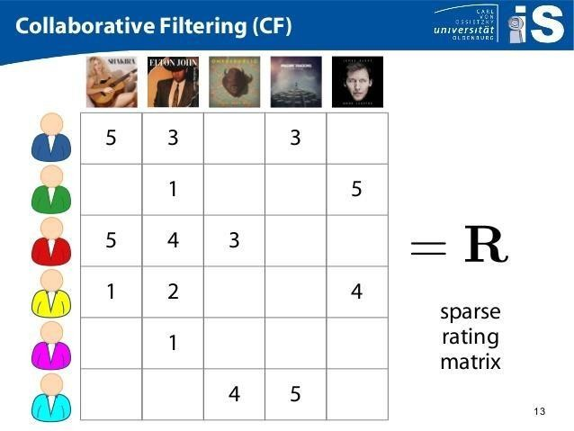

FIG 3.0 COLLABORATIVE FILTERING (CF)

### USER BASED FILTERING

Imagine that we want to recommend a movie to our friend *Stanley*. We could assume that similar people will have similar taste. Suppose that me and *Stanley* have seen the same movies, and we rated them all almost identically. But Stanley hasn’t seen *‘The Godfather: Part II’* and I did*.* If I love that movie, it sounds logical to think that he will too. With that, we have created an artificial rating based on our similarity.

Well, UB-CF uses that logic and recommends items by finding similar users to the *active user* (to whom we are trying to recommend a movie). A specific application of this is the user-based nearest neighbor algorithm. This algorithm needs two tasks:

In other words, we are creating a User-Item Matrix, predicting the ratings on items the active user has not see, based on the other similar users. This technique is memory based.

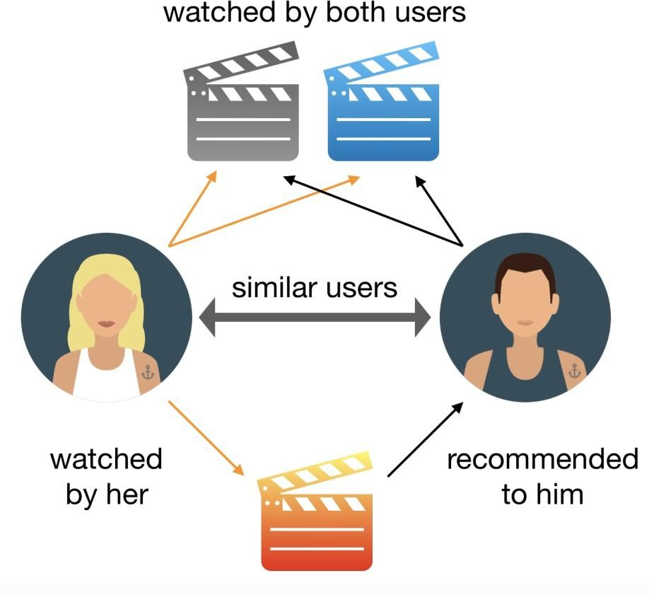

### FIG 3.1 USER BASED FILTERING

### KNN ALGORITHM

The ***K*-nearest neighbors algorithm** (***K*-NN**) is a non-parametric classification method first developed by Evelyn Fix and Joseph Hodges in 1951, and later expanded by Thomas Cover.It is used for Classification and regression. In both cases, the input consists of the *k* closest training examples in data set. The output depends on whether *k*-NN is used for classification or regression:

* In *k-NN classification*, the output is a class membership. An object is classified by a plurality vote of its neighbors, with the object being assigned to the class most common among its *k* nearest neighbors (*k* is a positive integer, typically small). If *k* = 1, then the object is simply assigned to the class of that single nearest neighbor.
* In *k-NN regression*, the output is the property value for the object. This value is the average of the values of *k* nearest neighbors.

*K-NN* is a type of classification where the function is only approximated locally and all computation is deferred until function evaluation. Since this algorithm relies on distance for classification, if the features represent different physical units or come in vastly different scales

Both for classification and regression, a useful technique can be to assign weights to the contributions of the neighbors, so that the nearer neighbors contribute more to the average than the more distant ones. For example, a common weighting scheme consists in giving each neighbor a weight of 1/*d*, where *d* is the distance to the neighbor.

The neighbors are taken from a set of objects for which the class (for *k*-NN classification) or the object property value (for *k*-NN regression) is known. This can be thought of as the training set for the algorithm, though no explicit training step is required.

1. Find the K-nearest neighbors (KNN) to the user ***a,*** using a similarity function ***w*** to measure the distance between each pair of users:

Image for post

1. Predict the rating that user ***a*** will give to all items the ***k*** neighbors have consumed but ***a*** has not. We look for the item ***j*** with the best predicted rating.

# THE OTHER METHOD

Various types of recommender system which we can classify as below

1. **Demographic Filtering** : This technique of recommendation filtering is based on the popularity basis for the gender specific users. The system simply e recommends the movies to users chaps slightly same demographic matches. Every user is different in this case so it is very simple to applied this approach. Idea is that the movies which are very popular and accepted by a bunch of people are having the highest probability of getting like by the users.

To understand this demographic filtering:

. Create a metric to rate the movie.

. Find the different metric score.

. Shorting the scores and then recommending the movies which are best rated for the users

Weighted Ratings (WR)= 𝑣

𝑣+𝑚

. 𝑅 + 𝑚

𝑣+𝑚

. 𝐶

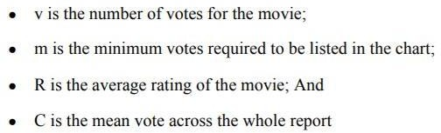

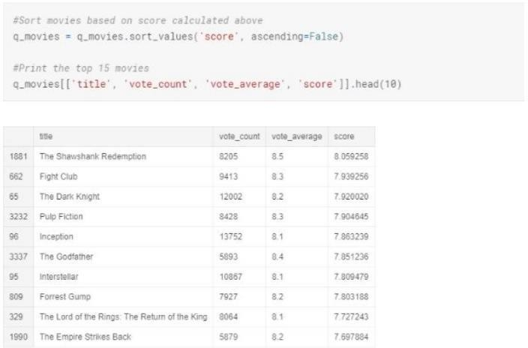

### Fig 3.2 -Demographic Filtering Method

1. **Content Based Filtering system:** In the content based filtering method we compare the different items with the user's interest profile. So basically the user profile holds the content that is is much more matching to use the form of the features. The previous actions or for the feedback is taken into account a generally takes into account the description of the content that has been edited by the users of different choices. Considering that example where a person buys some favourite item 'M' but item has been sold out and as a result he has to buy the item 'N' on the recommendation of some person as and 'N' has same type of matching features that the first one possesses. So this is simply the content based filtering which is demonstrated below

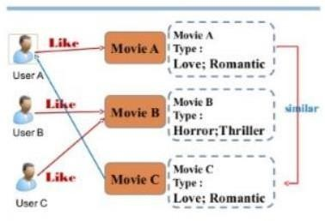

### Fig.-3.3 Content Based Filtering Method

So here numeric quantity that will be used to calculate the similarity between the two types of movies will be cosine similarity and we will calculate the score it is very very fast to calculate the the magnitude of the score which is obtained through the cosine similarity

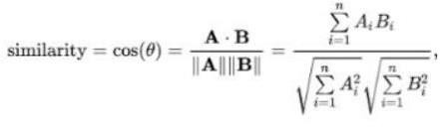

The steps involved in getting the movie recommendation are as below:

. Having the title find the index of that movie

. Calculate the cosine similarity scores for all the movies

. Arranging the scores in the order of highest priority first that is ascending order

. And then shorting the list based on the similarity scores.

. Getting the first 10 element of the list excluding the first one as it is the movie name in itself.

. Getting the top elements

Repeating above steps we will find the top movies based on the distances which it can get rhe best possible recommendation, the movies that have high probability of being liked by the general set of users will be displayed to the user by the recommender in the end and then in another technique we will try to find the users with different interest using the information collected through different activities an Indian in collaborative filtering will test all those users which have same type of interests to get the final set of movies to be recommended to the users individually. The cosine similarity is the cause of the angle between the two vectors where the vectors are non zero and the inner product space it is described as the dot product of the two vectors divide by by the product of the euclidean magnitude. In most cases cosine similarity is used to get preffered recommendations for users.

This method simply use the cosine distance between the vectors and then it uses similarity to calculate the score and then the preference of the user. For example movie with actors which define number of user likes and only few actors which a group of users don't like so we belie ve plotting a good sign angle between the user and the movie vectors which will generally be a large positive fraction, so angle is almost closely to be zero small distance of cosine will be present between the two vectors. Better metric somehow like the movie and cosine distance is large then the cosine similarity fails in this case we will approach in new method call decisio n tree to refine the recommender system. this method generally contains levels baby can appl y some conditions in a classification approach of refining the recommender system which try to find out if a user wants to what movie or not at all.

The advantages of the content based filtering are:

. Can recommend the unrated items.

. Can recommend the movies based on the ratings of the user The disadvantages of the content based filtering are:

. Can't work on the new user hasn't red kidney movie act

. It can't make the user likes with the un -likes .

1. **Collaborative based Filtering:** Content based filtering suffer from various limitations which is only capable of the suggesting movies having only one type of users preferences and then unable to provide recommendations in case of genres . However collaborative filtering based system provides much complexibility in finding the record between the similarity of user and the the likes of the users having similar interest. For measuring the similarity of users views cosine similarity or pearson's correlation. Taking example in the below Matrix every row has a user with column corresponding to the movies having the same similarity it also has the ratings of different movies which the user have given to each movie has a target user.

All the the collaborative filtering in case of user based is simple but it has also drawbacks the biggest challenges that the choices of the users where is with time. Pre computing the Matrix orphan let the problem of lower performance. So we can use the item based collaborative filtering which basically considers the items based on the similarity with the items and that it it find the similar matches with the target users the same similarity coefficients suggest pearson's correlation or Cosine similarity can be used. Item based collaborative filtering is most static in nature . Like blow example only one user which has related both Matrix and Titanic so similarity which stands between them is only one . There may be cases where we have millions of users and the similarity between those two different movies is very high as they have same rank for the user who have rated them both.

9

In collaborative filtering try to find out the users have which have name interest and similar li kes. In this case we don't use features of the item to recommend it but we use the classificatio n of users into clusters of similar types and then seperate each cluster into the order of the pre ference of the user. we can also use the cosine distance here which takes into account the user s with the similar interest greater the cosine small angle between the two user. Here we simpl y use the utility matrix we can assign the zero value to the sparse columns forming the calcul ations easy. Item based Colaborative filtering is preferred in general because it takes into acc ount the movie instead of the number of users which further only make the classification of th e movies and user much easier. Hence the user based collaborative filtering is not preferred b ecause it's simply only takes the user's into account and ignore the sparse values which create s the issues in bringing out the performance of the recommender system*.*

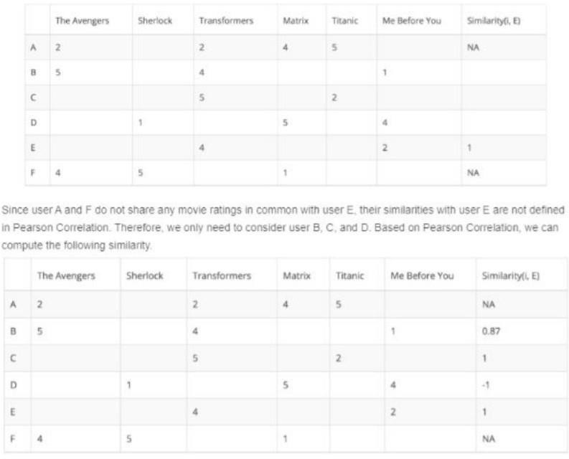

### Fig.-3.4 User Based Collaborative Filtering

So now we want our recommendation problem to be converted into a Optimisation problem . The most preferred common metric is a root mean square error(RMSE). Better the performance lower will be The RMSE value.

Advantages of collaborative filtering based systems are:

. It is simply content dependent

. It often reads the mind of people having same preferences

. Create real quality assessment of items.

Disadvantages of collaborative filtering based systems are:

. Early rater problem as the most common where the collaborative filtering method fails to provide ratings of the movie which has no user waiting.

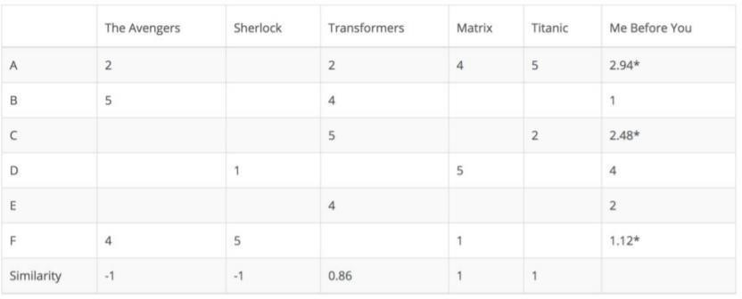. Sparsity problem is more common in this type of welding method where null values are in so much quantity that is difficult to find items which are rated by the majority of the people.

### Fig.-3.5 Item based Collaborative Filtering

1. **Hybrid Based Filtering:** It is simply a mixture of content based filtering and collaborative based filtering methods where we will take the input as the the userid and the title of the movie and the output will be e the similar movies shorted by the particular users based on the expected ratings. Expected ratings are calculated internally where the ideas from content and collaborative filtering are used to build a engine where movies are suggested to the particular user and then estimation of the ratings takes place

In the comparisons section below we will see how movies are determined through the hybrid technique of filtering where we have both used content based method as well as the collaborative based filtering method. It is clear that hybrid filtering method is is good in most of the cases and scenarios where it is difficult to distinguish or get the accuracy which the users can get the recommended movies.

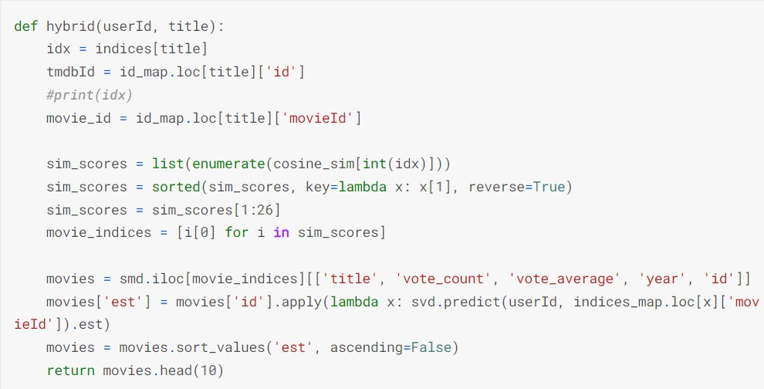 **Fig-3.6 Hybrid Filtering Method**

**Organization**

The following is a general outline of the report's structure:

Part 1: Describes the project's overall presentation, issue proclamation venture points, and scope.

Part 2: It provides an overview of current research in the topic. It explains in full all of the research, investigations, theories, and social gatherings that took place throughout the project.

Part 3: Discusses the project's framework and plan in order to forecast the correct outcome.

Part 4: Discusses the results and provides screenshots.

Part 5: Complete the project and submit a proposal for future work.

**SYSTEM DESIGN**

## Dataset

1. For Content and Collaborative Based Filtering:
   * Kaggle provided the data set. The Movie Recommendation System uses it as a standard Dataset.

* We used the movie dataset from 'Movie Lens(Kaggle)' for the project.
* Movies and ratings are taken into account.
* Total of 9743 movies
* Total of 100147 ratings
* MovieLens users were chosen at random.
* A unique id is assigned to each user and movie

1. For Hybrid filtering method :

Consists of 26,000,000 ratings and 750,000 taag applications applied to 45,000 movies by 270,000 users

Ratings are from 1-5 scale and taken from Group Lens Officially.

18

## Visualizing the no. of users Voted

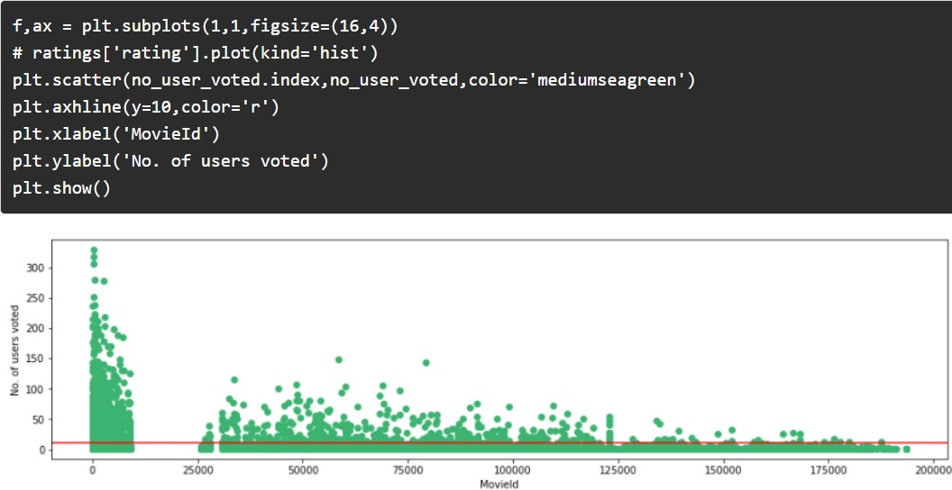

**Visualization the no. of Users Voted**

19

## Visualizing the no. of Votes by User

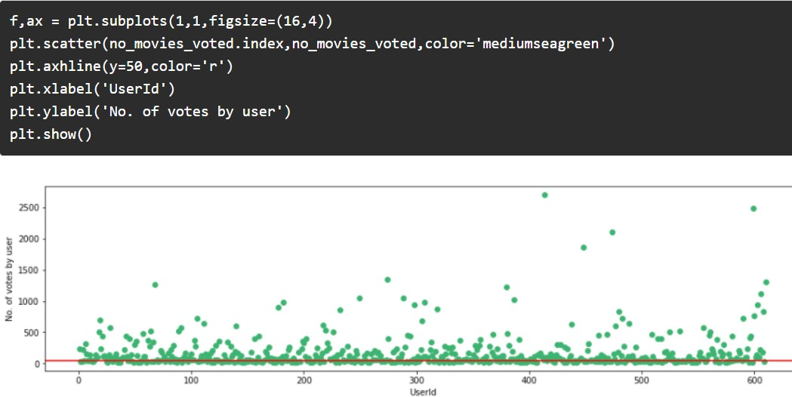

### Visualizing the no. of Votes by Users

20

## Algorithms Used

### K-Means Algorithm:

K means clustering algorithm just simply create the cluster inside a cluster which have same matching features in between them. The degree of closeness defines the the similarity basis as 2 how 2 points are related to each other. In this algorithm re simplify and centroid and then repeat the the process until optimum centroid is is calculated or found . It simply determines the best value for the K Centre points by iterative process and then assign each data point to the closest nearest centre of K value.The number of clusters found from the data is denoted simply by the notation 'K'. Simple unsupervised ml algorithm categorize the data points into subgroups even from the very less information about the data.

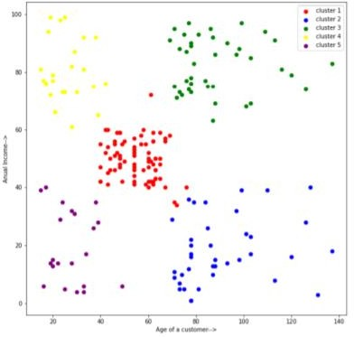

### K-Mean algorithm

21

### Cosine Similarity

The cosine similarity is the cause of the angle between the two vectors where the vectors are non zero and the inner product space it is described as the dot product of the two vectors divide by by the product of the euciledian magnitude. Smaller the angle higher the similarity so the cosine similarity is much much more preferable over the equilibrium distance because angle is smaller in case of cosine similarity.

### Singular Value Decomposition (SVD)

SVD is basically matrix factorization of a matrix into 3 matrices. It hols properties and convey some geometrical as well as the theoretical outputs in a linear transformation the mathematical way of representing. A SVD of a given Matrix is given by the formula:

A=UWV^T

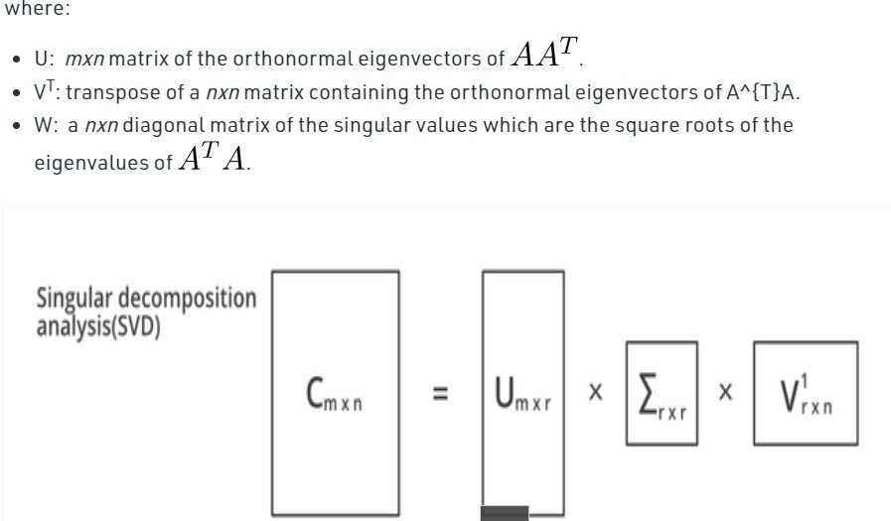

### SVD Algorithm

22

### RMSE (Root Mean Square Error)

RMSE is just basically the standard deviation of the predicted errors. Residue which are the measure of the regression where is the data points however it also shows this widespread of the residuals in the data points and also finds out the the best fit in the data .It is also used in forecasting ,regression analysis to get the verified results of the experiments . Better the performance lower will be The RMSE value.

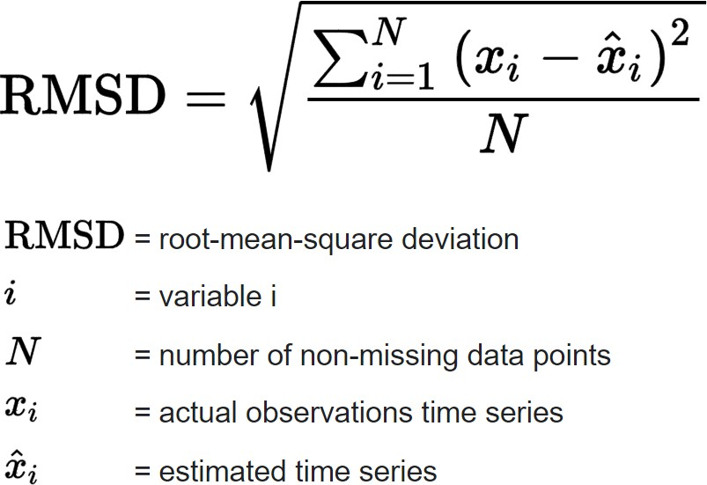

23

## Hardware and Software Requirements

* 4.2 GB RAM
* MS Window 7 and above Software Requirements
* Jupyter Notebook
* Wamdp Server
* Visual Studio Code
* Sublime Text
* MYSQL

### CONCEPTS REQUIREMENTS

* Machine Learning Algorithms
* Data Pre-processing Functions and tools
* scikit-learn
* seaborn
* knowledge of K-Means clustering

.NumPy is a Python programming language.

* Panda bears
* matplotlib (matplotlib)
* Cleaning of data
* 64bit processors are required

## CHAPTER 4

## MODULE DESCRIPTION

* 1. **SYSTEM STUDY**

A recommendation engine is a system that suggests products, services, information to users based on analysis of data. Notwithstanding, the recommendation can derive from a variety of factors such as the history of the user and the behaviour of similar users.

Recommendation systems are quickly becoming the primary way for users to expose to the whole digital world through the lens of their experiences, behaviours, preferences and interests. And in a world of information density and product overload, a recommendation engine provides an efficient way for companies to provide consumers with personalised information and solutions.

### BENEFITS

A recommendation engine can significantly boost revenues, Click-Through Rates (CTRs), conversions, and other essential metrics. It can have positive effects on the user experience, thus translating to higher customer satisfaction and retention.

Let’s take Netflix as an example. Instead of having to browse through thousands of box sets and movie titles, Netflix presents you with a much narrower selection of items that you are likely to enjoy. This capability saves you time and delivers a better user experience. With this function, Netflix achieved lower cancellation rates, saving the company around a billion dollars a year.

Although recommendation systems have been used for almost 20 years by companies like Amazon, it has been proliferated to other industries such as finance and travel during the last few years.

### DIFFERENT TYPES

The most common types of recommendation systems are CONTENT-BASED and COLLABORATIVE FILTERING recommendation systems. In collaborative filtering, the behavior of a group of users is used to make recommendations to other users. The recommendation

is based on the preference of other users. A simple example would be recommending a movie to a user based on the fact that their friend liked the movie. There are two types of collaborative models MEMORY-BASED methods and MODEL-BASED methods. The advantage of memory-based techniques is that they are simple to implement and the resulting recommendations are often easy to explain. They are divided into two:

* + - * **User-based collaborative filtering**: In this model, products are recommended to a user based on the fact that the products have been liked by users similar to the user. For example, if Derrick and Dennis like the same movies and a new movie come out that Derick like, then we can recommend that movie to Dennis because Derrick and Dennis seem to like the samemovies.
      * **Item-based collaborative filtering**: These systems identify similar items based on users’ previous ratings. For example, if users A, B, and C gave a 5-star rating to books X and Y then when a user D buys book Y they also get a recommendation to purchase book X because the system identifies book X and Y as similar based on the ratings of users A, B, and C.

Model-based methods are based on Matrix Factorization and are better at dealing with sparsity. They are developed using data mining, machine learning algorithms to predict users’ rating of unrated items. In this approach techniques such as dimensionality reduction are used to improve accuracy. Examples of such model-based methods include Decision trees, Rule-based Model, Bayesian Model, and latent factor models.

* + - * + **Content-based systems** use metadata such as genre, producer, actor, musician to recommend items say movies or music. Such a recommendation would be for instance recommending Infinity War that featured Vin Diesel because someone watched and liked The Fate of the Furious. Similarly, you can get music recommendations from certain artists because you liked their music. Content-based systems are based on the idea that if you liked a certain item you are most likely to like something that is similar to it.

### CHALLENGES A RECOMMENDATION SYSTEM FACE

1. Sparsity of data. Data sets filled with rows and rows of values that contain blanks or zero values. So finding ways to use denser parts of the data set and those with information is critical.
2. Latent association. Labelling is imperfect. Same products with different labelling can be ignored or incorrectly consumed, meaning that the information does not get incorporated correctly.
3. Scalability. The traditional approach has become overwhelmed by the multiplicity of products and clients. This becomes a challenge as data sets widen and can lead to performance reduction.

### DATA PRE-PROCESSING

For k-NN-based model, the underlying dataset ml-100k from the Surprise Python sci-unit was used. Shock may be a tight call in any case, to search out out regarding recommendation frameworks. It’s acceptable for building and examining recommendation frameworks that manage unequivocal rating data.

### MODEL BUILDING

Information is an element into a seventy fifth train take a look at and twenty fifth holdout take a look at. Grid Search CV completed over five - overlap, is employed to find the most effective arrangement of closeness live setup (sim_options) for the forecast calculation. It utilizes the truth measurements because the premise to get completely different mixes of sim options, over a cross-approval system.

### DATA SET USED:

we are using the Movie Lens Data Set. This dataset was put together by the Group lens research group at the University of Minnesota. It contains 1, 10, and 20 million ratings. Movie lens also has a website where you can sign up, contribute reviews and get movie recommendations.

### RECOMMENDATION VISUALIZATION:

**Fig-4.0**

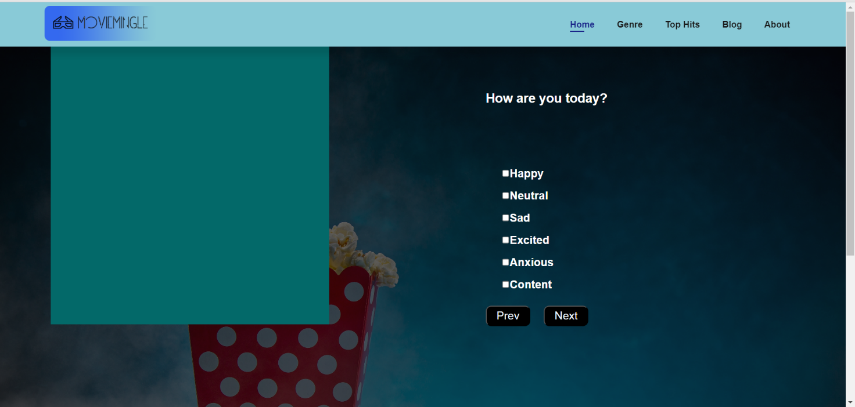

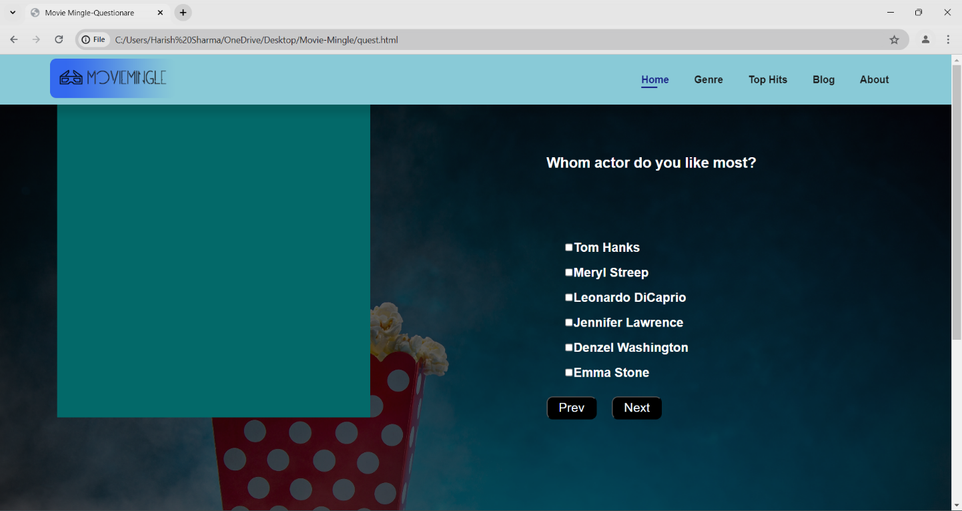 **Fig-4.1**

Fig-4.2

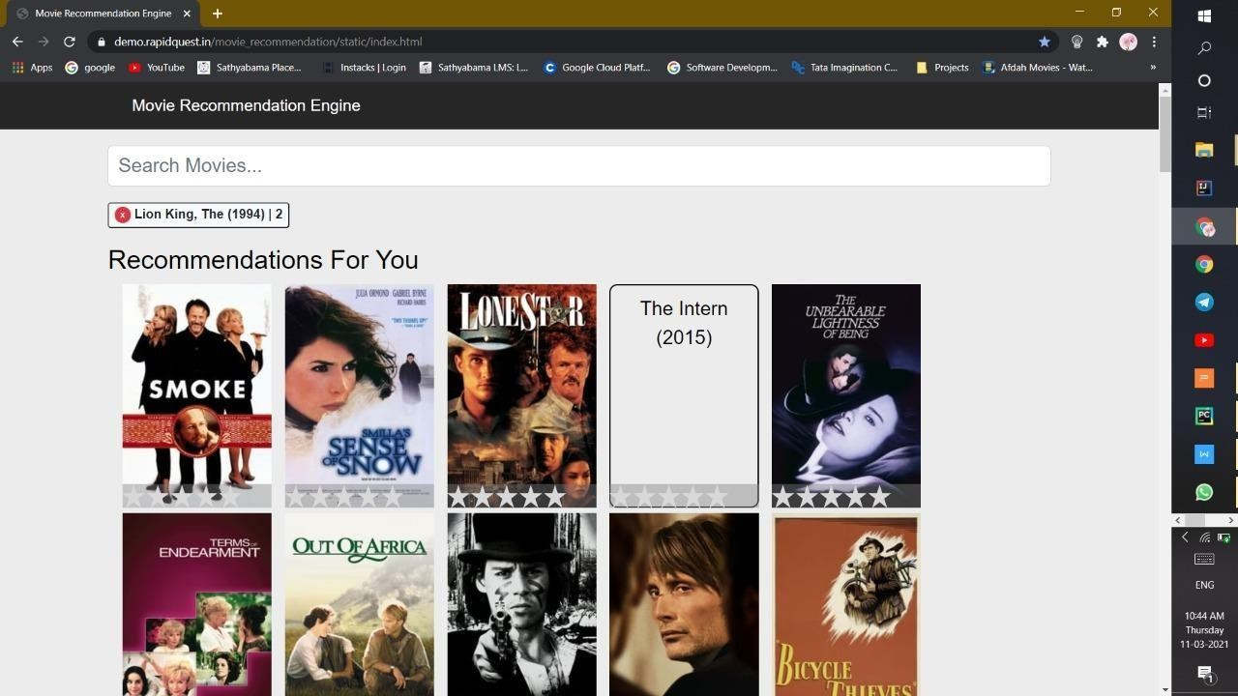

Fig-4.3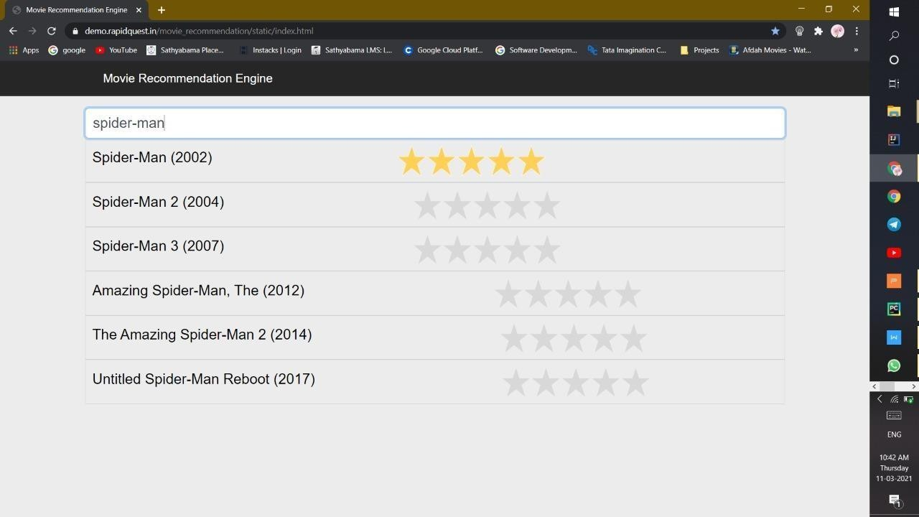

Fig-4.4

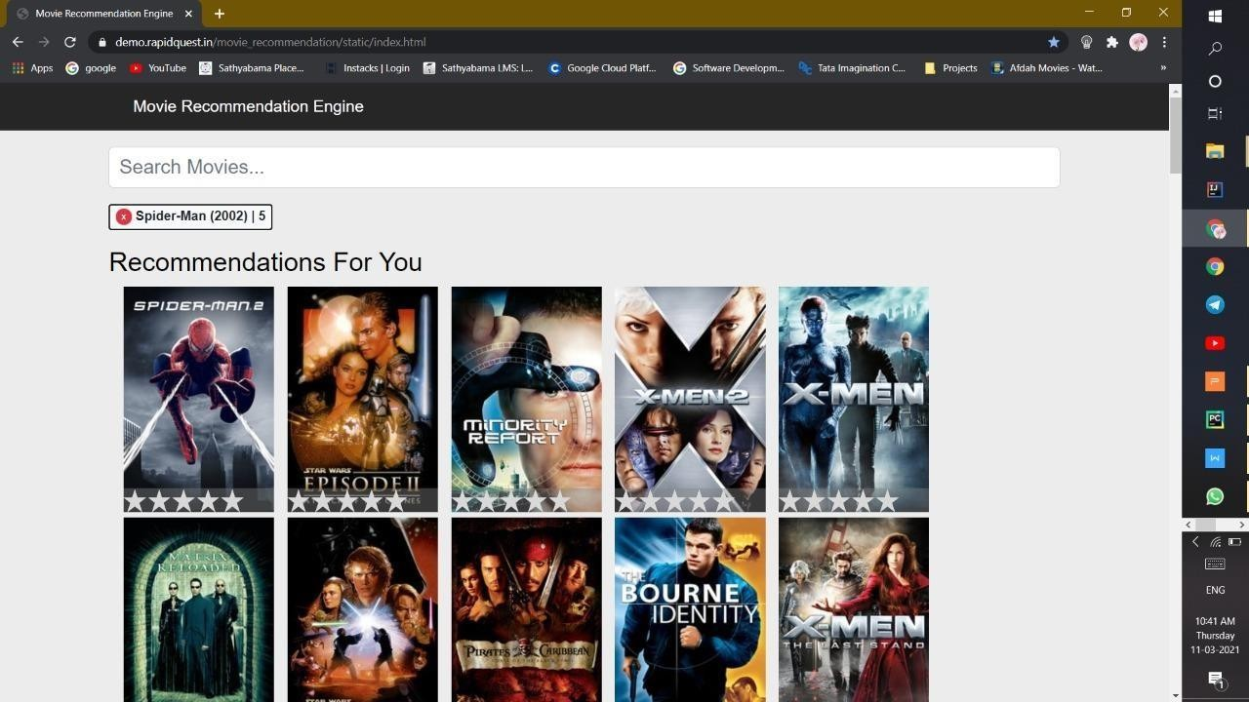

Fig-4.3

# PERFORMANCE ANALYSIS

**Filtering:**

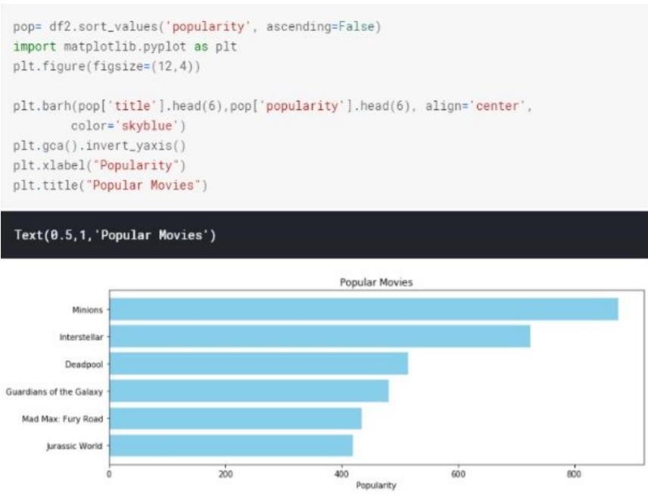Filtering the cause of short in the movies recommended which are best to the users based on the metric scores and personalized and generalized recommendations are recommended to the every users on the basis of the popularity which are generally like by the average audience.

## Demographic Filtering Output

**2 Content Based Filtering:**

User profile holds the content that is is much more matching to use the form of the features. The previous actions or for the feedback is taken into account a generally takes into account the description of the content that has been edited by the users of different choices.

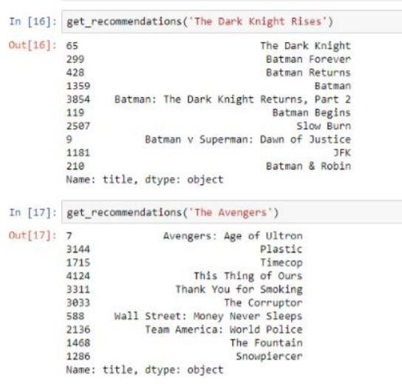

### Content Based Filtering Output

**3.) Collaborative based Filtering:** In the collaborative filtering behaviour used here item based collaborative filtering where we have taken 3 different types of metrics and varied the results accordingly. Brief comparison of three of the metric used in the collaborative filtering are are shown with the movies recommended from them based on the the bounds set to the number of users and a number of ratings by a user to a movie.

Metric =”Cosine” Cosine similarity, or the cosine kernel, **computes similarity as the normalized dot product of X and Y**: K(X, Y) = <X, Y> / (||X||*||Y||) On L2-normalized data, this function is equivalent to linear_kernel.

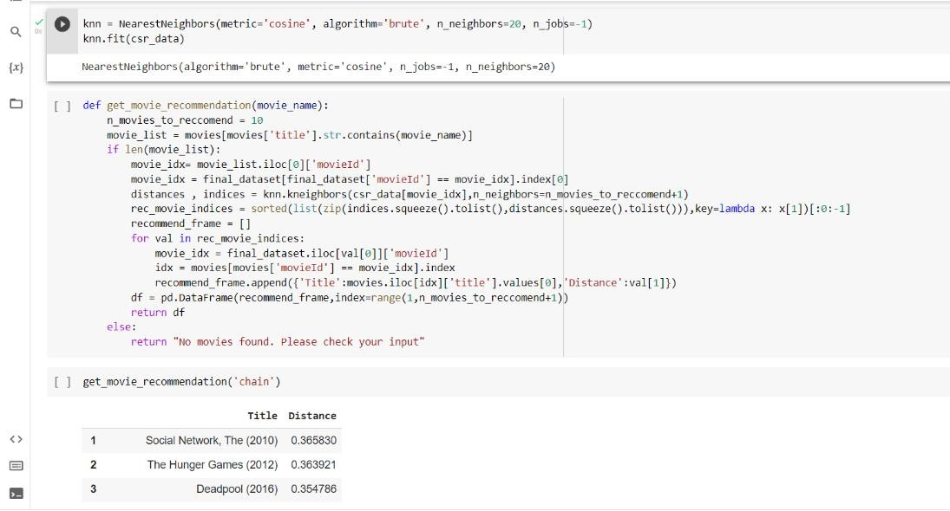

### 

### Collaborative Based Filtering Method(Metric =Cosine) Output

Metric=”Cityblock”-> This function simply returns the valid pairwise distance metrics. It exists to allow for a description of the mapping for each of the valid strings.

The function for the cityblock is as below

‘cityblock’ =metrics.pairwise.manhattan_distances

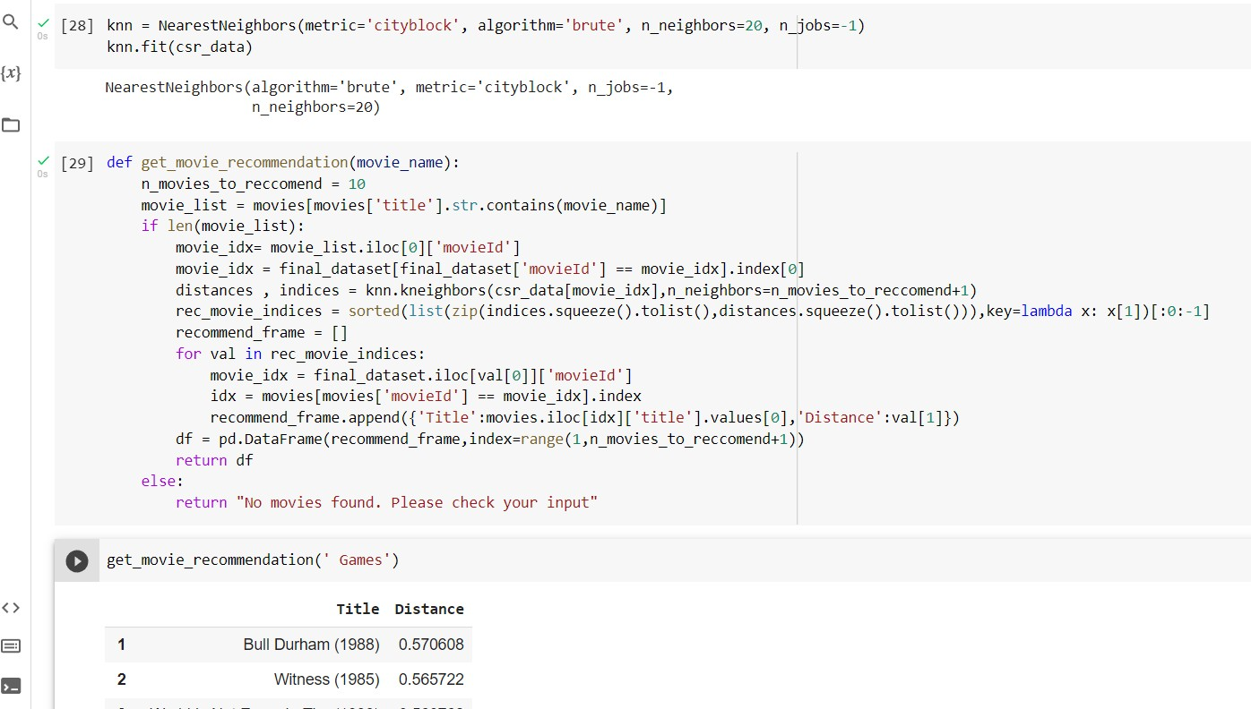

### 

### Collaborative Based Filtering Method(Metric =Cityblock) Output

Metric=”Minkowski”-> It is a metric intended for real-valued vector spaces. We can calculate Minkowski distance only in a normed vector space, which means in a space where distances can be represented as a vector that has a length and the lengths cannot be negative.

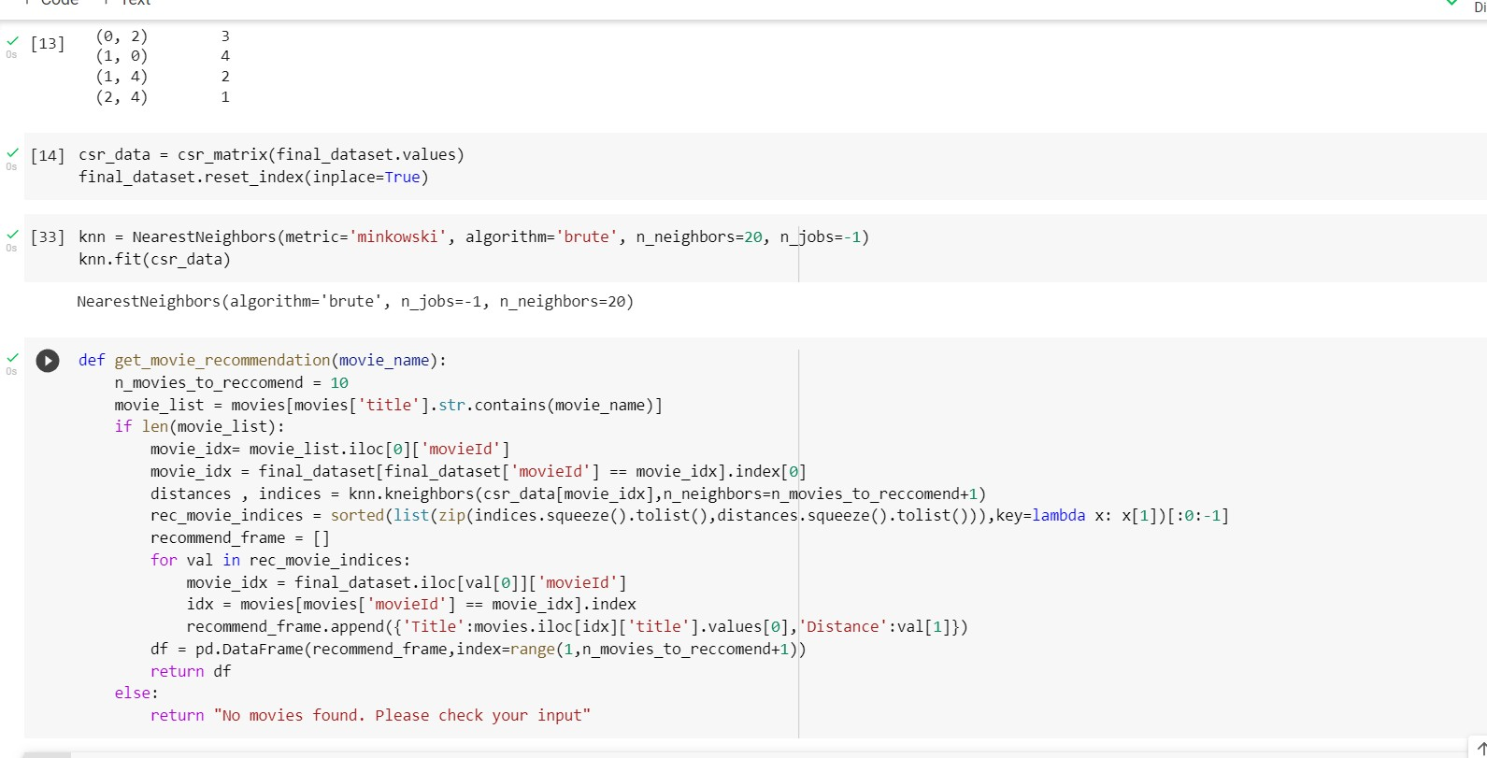

### Collaborative Based Filtering Method(Metric =Minkowski) Output

**4) Hybrid Based filtering:** It is simply a mixture of content based filtering and collaborative based filtering methods where we will take the input as the the userid and the title of the movie and the output will be e the similar movies shorted by the particular users based on the expected ratings. Expected ratings are calculated internally where the ideas from content and collaborative filtering are used to build a engine where movies are suggested to the particular user and then estimation of the ratings takes place.

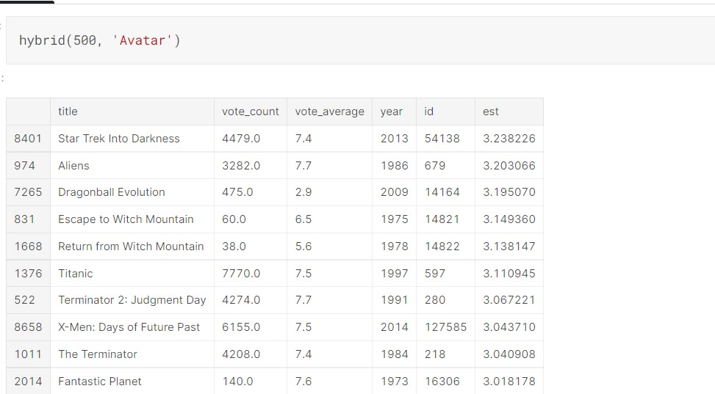

### Hybrid Based Filtering Output

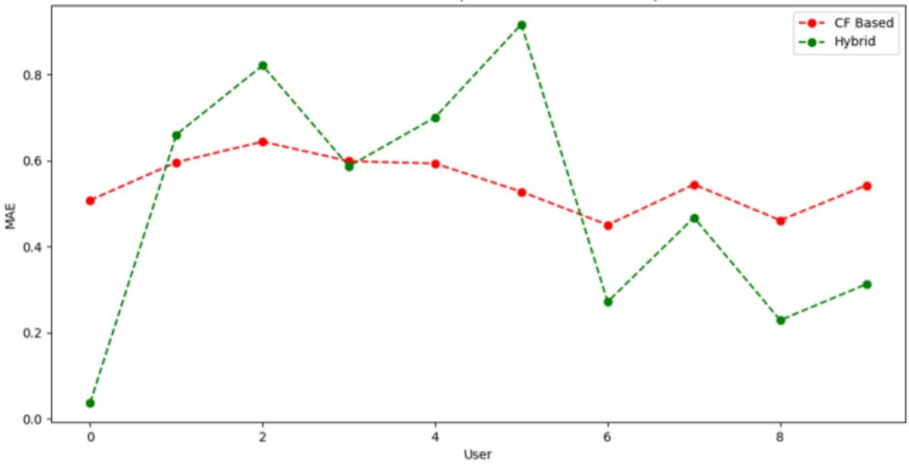

**Comparitative output**

Here we can see that the hybrid filtering technique stands good in in overcoming the the issues faced in the content based filtering technique and the collaborative based filtering method we can generalize from the method of root mean square error that the value for hybrid filtering method is less so performance is higher for hybrid case. While we can say that collaborative filtering technique stands good only in terms of the quality perspective but when it comes to both qualitative and quantitative achievement of the result will prefer hybrid filtering technique where the all flaws. While content based filtering technique only outperform the collaborative in terms of similarity e the collaborative filtering technique can you recommend one item to the other item of the similar interest, the overall flaws can be removed by the hybrid based collaborative filtering with two or more examination techniques are combined to gain the better performance with the less possibilities of drawback of this system. In general in case of hybrid filtering techniques the collaborative filtering technique is combined with some other type of filtering technique to avoid the ramp up problem and thus it outperforms the the major drawbacks of the system in case if we prefer to use single content based or collaborative filtering technique.

So hybrid filtering recommender simply allows the user to select his own choices from a given data which contain some attributes or some set of values which contain user specific values and then recommend then the best movie which is based on the similarities based calculating the the accumulator weight and then applies the algorithm which is in our case K mean algorithm. Expected ratings are calculated internally where the ideas from content and collaborative filtering are used to build a engine where movies are suggested to the particular user and then estimation of the ratings takes place. So in the the process of getting different results from different algorithms and techniques hybrid approach is preferred to be better one between the content and collaborative filtering techniques which simply overcomes the drawbacks of the the single algorithm and then tries to improve the performance of the overall recommender system. Moreover some other techniques like classification clustering can be used to get the best of the recommendations which would simply increase our accuracy for the recommender system. So the the better performance can be achieved in the end by a hybrid based filtering technique which is why it is most preferable over the other two techniques.

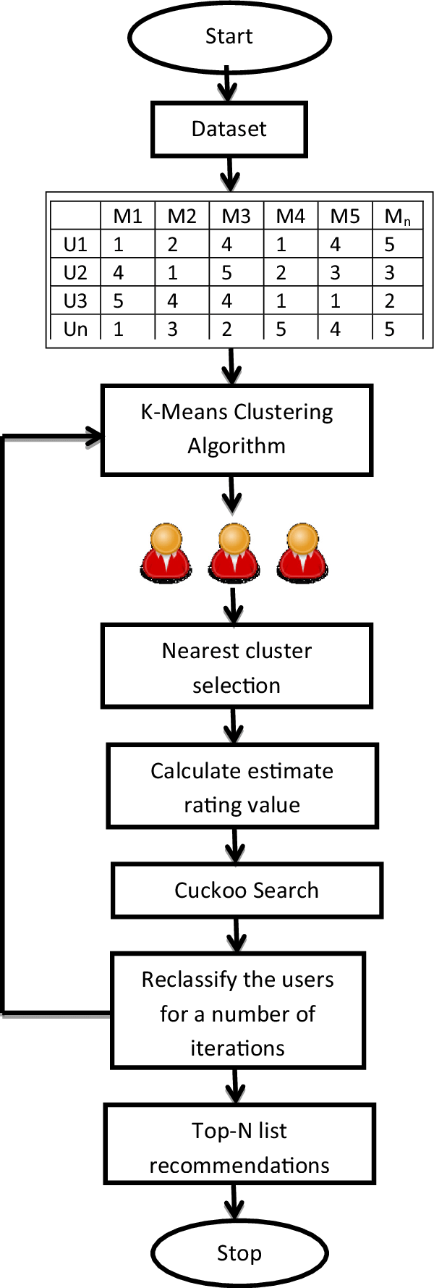

**System Framework**

**CHAPTER 5**

**RESULT CONCLUSION AND DISCUSSION**

* 1. **CONCLUSION**

In the last few decades, recommendation systems have been used, among the many available solutions, in order to mitigate information and cognitive overload problem by suggesting related and relevant items to the users. In this regards, numerous advances have been made to get a high-quality and fine-tuned recommendation system. Nevertheless, designers face several prominent issues and challenges. Although, researchers have been working to cope with these issues and have devised solutions that somehow and up to some extent try to resolve these issues, however we need much to do in order to get to the desired goal. In this research article, we focused on these prominent issues and challenges, discussed what has been done to mitigate these issues, and what needs to be done in the form of different research opportunities and guidelines that can be followed in coping with at least problems like latency, sparsity, context-awareness, grey sheep and cold-start problem.

### RESULT

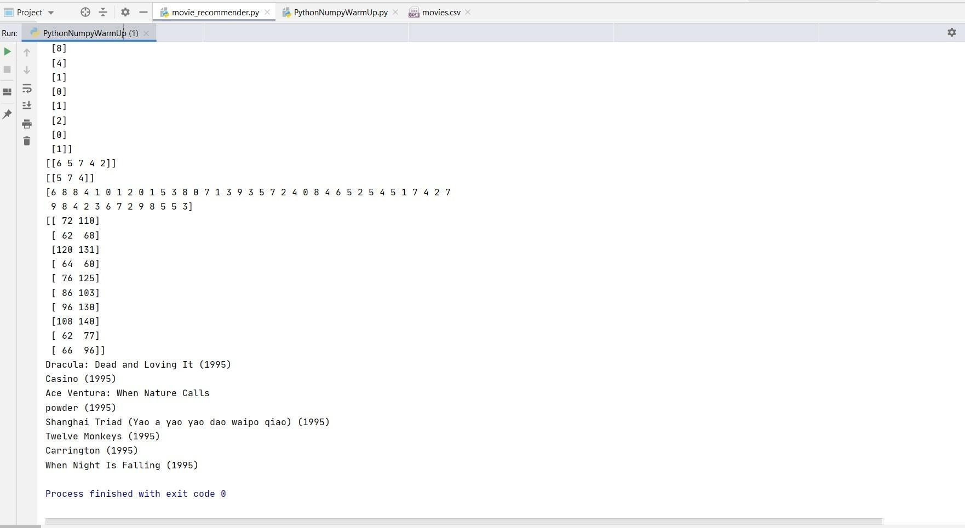

FIG 5.0 OUTPUT

### C.PAPER PUBLICATION

#### Title: MOVIE RECOMMENDATION SYSTEM

ADDANKI HARSHA[1] , S AMIRTHAVARSHINI[2] , A CHRISTY [3] [1][2] UG Student, Dept. of CSE,

Sathyabama Institute of Science and Technology, Chennai, India [3]Associate professor, Dept. of CSE, Sathyabama Institute of Science and Technology, Chennai, India

**ABSTRACT**: - Recommender System may be a framework that appears to anticipate or channel inclinations as indicated by the client's choices. Recommender frameworks square measure utilized in Associate in Nursing assortment of zones together with films, music and things by and enormous. The calculation rates the items and shows the shopper the items that they might rate deeply. An illustration of suggestion in real world is that the purpose at that you visit Amazon and you notice that a number of things square measure being prescribed to you same as in Netflix or music streaming and then on, A recommender framework may be an easy calculation whose purpose is to allow the foremost applicable information to a shopper by finding styles in a very dataset. The calculation rates the items and shows the shopper the items that they might rate exceptionally. Associate in nursing illustration of suggestion in real world is that the purpose at that you visit Amazon and you notice that a number of things square measure being prescribed to you or once Netflix prescribes sure motion photos to you.

### I INTRODUCTION

Suggestion frameworks square measure the frameworks that square measure used to accumulate shopper fascination by understanding the client's style. These frameworks have currently become thought because of their capability to allow customised substance to shoppers that square measure of the client's advantage. Nowadays an outsized range of things square measure recorded on net business sites that create it tough to get a results of our ideal call. This is often the place wherever these frameworks assist United States by apace suggesting United States with the perfect things. Proposal frameworks facilitate shoppers notice and choose things (e.g., books, motion photos, eateries) from the big variety accessible on the online or in different electronic knowledge sources. Given a massive arrangement of things and a portrayal of the client's needs, they gift to the consumer a bit arrangement of the items that square measure applicable to the depiction. Also, a movie proposal framework provides a degree of solace and personalization that assists the

consumer with collaborating the framework and watch motion photos that take into consideration his needs. Giving this degree of solace to the consumer was our essential inspiration in choosing film proposal framework as our BE Project. The most reason for our framework is to impose motion photos to its shoppers obsessed with their review history and evaluations that they provide. The framework can likewise impose totally different E-trade organizations to advertise their things to specific shoppers obsessed with the categoryof films they like. Made-to-order proposal motors facilitate a large variety of people slender the universe of doubtless movies to accommodate their exceptional tastes. Community separating and content based mostly winnow square measure the square measure prime ways in which to traumatize provide suggestion to shoppers. The 2 of them square measure best relevant in specific things in light-weight of their explicit smart and dangerous times. During this paper we've projected a emulsified methodology with the tip goal that each the calculations supplement one another consequently rising presentation and exactness of the of our framework.

### RELATED WORK

Film proposals utilizing a number of procedures are widely targeted within the previous a few years. Models incorporate a proposal framework utilizing the ALS calculation, a suggestion smitten by the coefficient procedure, thing likeness based mostly synergistic separation. These procedures would like earlier information regarding the appraisals for the motion photos that square measure made by the shopper.

These strategies significantly use film attentiveness datasets for assessment functions. Nonetheless, these frameworks aren't somewhat actual, and analysis is continuous to boost the continuing exhibition of those frameworks. Style and Implementation of cooperative Filtering Approach utilizing KNN Cui, Bei-Bei[2] has self-addressed the suggestion framework Utilizing the rating and likeness among the 2 clients; the framework prescribes an issue to the shopper for the dynamic. At that time separate the film informational index into Associate in nursing unrated and evaluated take a look at set with the help of the KNN model. It will counsel the motion photos to the obscure shoppers through shopper tour of duty information, furthermore, it will create new and not thought film suggestions as indicated by the film's set of experiences and score. The info set during this approach is that the MYSQL data base. The tour of duty framework for a shopper can snap the client's outer and interior conduct qualities, and these attributes square measure place away within the shopper information base through a login module for the shopper. The to a lower place figure.1.Portrays their compelling technique of approach for a collective sifting approach utilizing KNN. Comparison with completely different calculations. In [4], Goutham Miryala projected an identical investigation of ALS on completely different calculations. still, it's seen that utilizing a additional broad making ready dataset of 80-20 (Training - Testing) yields a model that includes a lower RMSE once contrasted with the 60-40 (Preparing - Testing) dataset. The result shows that the upper regularization boundary expands RMSE and therefore the different method around. The ALS calculation is contrasted and SVD, KNN, and Normal Indicator, and therefore the outcomes show that ALS is that the best calculation for the suggestion framework.

### 

### EXISTING SYSTEM

The most well-known sorts of suggestion frameworks square measure content-based and shared separation recommender frameworks. In shared separation, the conduct of a gatheringof shoppers is employed to form proposals to completely different shoppers. The suggestion depends on the inclination of various shoppers. An easy model would bring down a movie to a shopper smitten by the method that their companion treasured the film. There square measure 2 styles of communitarian models Memory-based ways and Model-based techniques. The top of memory-based strategies is that {they square straightforward to actualize and therefore the succeeding suggestions are frequently straightforward to clarify. they're divided into two: User-based synergistic sifting: during this model, things square measure prescribed to a shopper smitten by the method that the things are most wellliked by shoppers just like the shopper. For example : if Derrick and Dennis like similar films and another film begin that Derick like, at that time we will bring down that film to Dennis in lightweight of the very fact that Derrick and Dennis seem to love similar motion photos. Item-based cooperative separating: These frameworks acknowledge comparative things smitten by clients' past evaluations. for example, if shoppers A, B, and C gave a 5-star rating to books X and Y then once a shopper D purchases book Y they likewise get a suggestion to shop for book X on the grounds that the framework distinguishes book X and Y as comparative smitten by the evaluations of shoppers A, B, and C. Model-put a long ways square measure based mostly with relevance Matrix resolving and square measure higher at managing scantiness. They’re created utilizing data mining, AI calculations to anticipate clients' evaluating of unrated things. During this methodology procedures, for instance, spatiality decrease square measure used to boost truth. Instances of such model-based ways incorporate call trees, Rule-based Model, theorem Model, and inert issue models. Content-based frameworks use data like category, maker, someone, entertainer to counsel things say motion photos or music. Such a proposal would be for instance suggesting eternity War that enclosed Vin Diesel since someone watched and enjoyed The Fate of the Furious. Also, you'll get music proposals from specific specialists since you really liked their music. Content-put along frameworks square measure based mostly with relevance the chance that within the event that you simply most well-liked a particular issue you're well on the thanks to like one thing that's love it.

### DISADVANTAGES OF THE EXISTING SYSTEM

* + It does not work for one more shopper UN agency has not appraised any issue nevertheless as enough appraisals square measure needed substance based mostly recommender assesses the shopper inclinations and provides actual proposals. Complex interface
  + No suggestion of lucky things.
  + Limited Content Analysis-The recommender does not work if the framework neglects to acknowledge the items cap a shopper likes from the items that he does not look after.

### PROPOSED SYSTEM

This framework are often improved by building a Memory-Based cooperative Filtering based mostly framework. For this case, we'd partition the data into a preparation set and a take a look at set. We'd at that time use strategies, for instance, trigonometric function similitude to register the equivalence between the motion photos. Associate in nursing possibility is to assemble a Model-based cooperative Filtering framework. Shared separation calculation is classed as shopper based mostly shared separation calculation and task based mostly Shared separation. The essential standards of the 2 is extremely comparable, and this half essentially presents the shopper based mostly Shared separation suggestion calculation. The

essential thought of shared separation suggestion calculation is to present the info of comparable interest shoppers to protest clients for example envision Client A loves film A, B, C, and shopper C preferences film B, D, so we will presume that the inclinations of shopper Associate in Nursing and shopper C are noticeably like. Since shopper a loves film D conjointly, so we can derive that the shopper A might likewise treasure issue D, thence issue D would be prescribed to the shopper. The essential thought of the calculation depends on records of history score of shopper. Find the neighbour shopper as u' UN agency has the comparable interest with target client u, and subsequently counsel the items that the neighbour client u' needed to focus on shopper u, the foresee score that target client u might offer on the issue is no inheritable by the score count of neighbour shopper u' on the issue. The calculation comprises of 3 elementary advances: shopper closeness computation, closest neighbour determination and forecast score computation. 3 KNN communitarian separation calculation KNN shared separating calculation, which is a synergistic separation calculation joined with KNN calculation, use KNN calculation to decide on neighbour s. the elemental steps of the calculation square measure shopper equivalence estimation, KNN Closest neighbour alternative and foresee score.



### FIG 5.1 OVERVIEW OF THE PROPOSED SYSTEM

**ADVANTAGES OF THE PROPOSED SYSTEM**

* + It is subject to the association between shoppers that suggests that it's contentautonomous. Scalable client administrations.
  + CF recommender frameworks will propose lucky things by noticing comparative leaning individuals' conduct.
  + They will create real quality analysis of things by considering completely different folks teams insight.

### MODULES DESCIRPTION

* The task is especially divided into 2 phases:
  + Data Pre-processing
  + Model Building

#### k-NN-based and MF-based Collaborative Filtering — Data Pre-processing

For k-NN-based and MF-based models, the underlying dataset ml-100k from the Surprise Python sci-unit was used. Shock may be a tight call in any case, to search out out regarding recommender frameworks. It’s acceptable for building and examining recommender frameworks that manage unequivocal rating data

#### k-NN- based Collaborative Filtering — Model Building

Information is an element into a seventy fifth train take a look at and twenty fifth holdout take a look at. Grid Search CV completed over five - overlap, is employed to find the most effective arrangement of closeness live setup (sim_options) for the forecast calculation. It utilizes the truth measurements because the premise to get completely different mixes of sim options, over a cross-approval system.

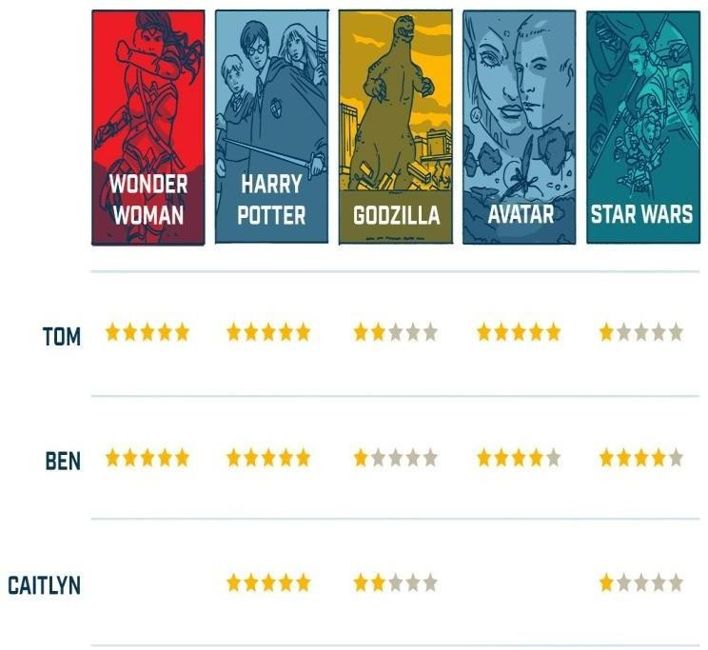

**FIG 5.2SAMPLE PICTURE OF RATING**



 **FIG 5.3 DATA SET**

**FIG 5.4 OUTPUT**

**CONCLUSION**

This paper incorporates a summation survey of writing considers known with the film proposal framework smitten by cooperative separating. Numerous methodologies, Userbased separating, Item-based separation, subbing least sq. strategies,KNN strategy, and for execution estimation of those framework Root mean sq. technique (RMSE)[3], Mean sq. method(MSE), giant scale and miniature received the centre of f- measure were used in investigations. Every investigation has its qualities and constraints. In future work, a movie suggestion will improve by utilizing the Pytorch library whereby a model would be ready to get the

### dormant (Hidden) factors. Under the state of monumental information, the requirements of film proposal framework from film beginner square measure increasing. This text plans and executes a complete film suggestion framework model smitten by the KNN calculation, community separation calculation and proposal framework technology[18]. We tend to provide a purpose by purpose set up and advancement interaction, and take a look at the soundness and high productivity of examination framework through adept take a look at. This paper has reference importance for the development of customized suggestion Innovation.

### 

### REFERENCES

1. Bobadilla J, Ortega F, Hernando A, Gutiérrez A (2013) recommendation systems survey. Knowl Based Syst 46:109–132. https://doi.org/10.1016/j.knosys.2013.03.012
2. Cui, Bei-Bei. (2017). Design and Implementation of Movie Recommendation System Based on Knn Collaborative Filtering Algorithm. ITM Web of Conferences. 12. 04008. 10.1051/itmconf/20171204008.
3. Fadhel Aljunid, Mohammed & D H, Manjaiah. (2018). Movie recommendation System Based on Collaborative Filtering Using Apache Spark. [https://doi.org/10.1007/978- 981-13-1274-8_22](https://doi.org/10.1007/978-%20981-13-1274-8_22)
4. Miryala, Goutham & Gomes, Rahul & Dayananda, Karanam. (2017). COMPARATIVE ANALYSIS OF MOVIE RECOMMENDATION SYSTEM USING COLLABORATIVE FILTERING IN SPARK

ENGINE. Journal of Global Research in Computer Science. 8. 10-14.

1. Banerjee, Anurag & Basu, Tanmay. (2018). Yet Another Weighting Scheme for Collaborative Filtering Towards Effective Movie Recommendation.
2. Zhao, Zhi-Dan & Shang, Ming Sheng. (2010). UserBased Collaborative-Filtering Recommendation Algorithms on Hadoop. 3rd International Conference on Knowledge Discovery and Data Mining, WKDD 2010. 478- 481. <https://doi.org/10.1109/WKDD.2010.54>.
3. Kharita, M. K., Kumar, A., & Singh, P. (2018). ItemBased Collaborative Filtering in Movie Recommendation in Real-time. 2018 First International Conference on Secure Cyber Computing and Communication (ICSCCC). DOI:10.1109/icsccc.2018.8703362
4. A. V. Dev and A. Mohan, "Recommendation system for big data applications based on the set similarity of user preferences," 2016 International Conference on Next Generation Intelligent Systems (ICNGIS), Kottayam, 2016, pp. 1-6. DOI: 10.1109/ICNGIS.2016.7854058
5. Subramaniyaswamy, V., Logesh, R., Chandrashekhar, M., Challa, A. and Vijayakumar, V. (2017) ‘A personalized movie recommendation system based on collaborative filtering,’ Int. J. HighPerformance Computing and Networking, Vol. 10, Nos. 1/2, pp.54–63.
6. Thakkar, Priyank & Varma (Thakkar), Krunal & Ukani, Vijay & Mankad, Sapan & Tanwar, Sudeep. (2019). Combining UserBased and Item-Based Collaborative Filtering Using Machine Learning:

Proceedings of ICTIS 2018, Volume 2. 10.1007/978-981-13-1747- 7_17

1. Wu, Ching-Seh & Garg, Deepti & Bhandary, Unnathi. (2018). Movie Recommendation System Using Collaborative Filtering. 11-15. 10.1109/ICSESS.2018.8663822.
2. Verma, J. P., Patel, B., & Patel, A. (2015). Big data analysis: Recommendation system with Hadoop framework. In 2015 IEEE International Conference on Computational Intelligence & Communication Technology (CICT). IEEE.
3. Zeng, X., et al. (2016). Parallelization of the latent group model for group recommendation algorithm. In IEEE International Conference on Data Science in Cyberspace (DSC). IEEE.
4. Katarya, R., & Verma, O. P. (2017). An effective collaborative movie recommendation system with a cuckoo search. Egyptian Informatics Journal, 18(2), 105–112. DOI:10.1016/j.eij.2016.10.002
5. Phorasim, P., & Yu, L. (2017). Movies recommendation system
6. Using collaborative filtering and k-means. DOI:10.19101/IJACR.2017.729004 M Shamshiri, GO Sing, YJ Kumar, International Journal of Computer Information Systems and Industrial Management Applications(2019).
7. Sri, M. N., Abhilash, P., Avinash, K., Rakesh, S., & Prakash, C. S. (2018). Movie recommendation System using Item-based Collaborative Filtering Technique. [18] Research.ijcaonline.org [19]

]GroupLens, Movielens Data, 2019 , <http://grouplens.org/datasets/movielens/>

1. Bobadilla J, Ortega F, Hernando A, Gutiérrez A (2013) Recommender systems survey. Knowl Based Syst 46:109–132. <https://doi.org/10.1016/j.knosys.2013.03.012>
2. Cui, Bei-Bei. (2017). Design and Implementation of Movie Recommendation System Based on Knn Collaborative Filtering Algorithm. ITM Web of Conferences. 12. 04008. 10.1051/itmconf/20171204008.
3. Fadhel Aljunid, Mohammed & D H, Manjaiah. (2018). Movie Recommender System Based on Collaborative Filtering Using Apache Spark. [https://doi.org/10.1007/978- 981-13-1274-8_22](https://doi.org/10.1007/978-%20981-13-1274-8_22)
4. Miryala, Goutham & Gomes, Rahul & Dayananda, Karanam. (2017). COMPARATIVE ANALYSIS OF MOVIE RECOMMENDATION SYSTEM USING COLLABORATIVE FILTERING IN SPARK ENGINE.

Journal of Global Research in Computer Science. 8. 10-14.

1. Banerjee, Anurag & Basu, Tanmay. (2018). Yet Another Weighting Scheme for Collaborative Filtering Towards Effective Movie Recommendation.
2. Zhao, Zhi-Dan & Shang, Ming Sheng. (2010). UserBased Collaborative-Filtering Recommendation Algorithms on Hadoop. 3rd International Conference on Knowledge Discovery and Data Mining, WKDD 2010. 478- 481. <https://doi.org/10.1109/WKDD.2010.54>
3. Kharita, M. K., Kumar, A., & Singh, P. (2018). ItemBased Collaborative Filtering in Movie Recommendation in Real-time. 2018 First International Conference on Secure Cyber Computing and Communication (ICSCCC). DOI:10.1109/icsccc.2018.8703362
4. A. V. Dev and A. Mohan, "Recommendation system for big data applications based on the set similarity of user preferences," 2016 International Conference on Next Generation Intelligent Systems (ICNGIS),

Kottayam, 2016, pp. 1-6. DOI: 10.1109/ICNGIS.2016.7854058

1. Subramaniyaswamy, V., Logesh, R., Chandrashekhar, M., Challa, A. and Vijayakumar, V. (2017) ‘A personalized movie recommendation system based on collaborative filtering,’ Int. J. HighPerformance Computing and Networking, Vol. 10, Nos. 1/2, pp.54–63.
2. Thakkar, Priyank & Varma (Thakkar), Krunal & Ukani, Vijay & Mankad, Sapan & Tanwar, Sudeep. (2019). Combining UserBased and Item-Based Collaborative Filtering Using Machine Learning: Proceedings of ICTIS 2018, Volume 2. 10.1007/978-981-13-1747- 7_17Wu, Ching-Seh & Garg, Deepti & Bhandary, Unnathi. (2018). Movie Recommendation System Using Collaborative Filtering. 11-15. 10.1109/ICSESS.2018.8663822.
3. Verma, J. P., Patel, B., & Patel, A. (2015). Big data analysis: Recommendation system with Hadoop framework. In 2015 IEEE International Conference on Computational Intelligence & Communication Technology (CICT). IEEE.
4. Zeng, X., et al. (2016). Parallelization of the latent group model for group recommendation algorithm. In IEEE International Conference on Data Science in Cyberspace (DSC). IEEE.
5. Katarya, R., & Verma, O. P. (2017). An effective collaborative movie recommender system with a cuckoo search. Egyptian Informatics Journal, 18(2), 105–112. DOI:10.1016/j.eij.2016.10.002
6. Phorasim, P., & Yu, L. (2017). Movies recommendation system
7. Using collaborative filtering and k-means. DOI:10.19101/IJACR.2017.729004 M Shamshiri, GO Sing, YJ Kumar, International Journal of Computer Information Systems and Industrial Management Applications(2019).
8. Sri, M. N., Abhilash, P., Avinash, K., Rakesh, S., & Prakash, C. S. (2018). Movie Recommender System using Item-based Collaborative Filtering Technique.
9. Research.ijcaonline.org
10. ]GroupLens, Movielens Data, 2019 , <http://grouplens.org/datasets/movielens/>